DAA LAB ASSIGNMENT – 2
Course: Design and Analysis of Algorithms (DAA)
Student Name: Lavanyadevi K
Student Reg. No: CH.SC.U4CSE24226
Student Department/Class: B. Tech CSE – C (2nd yr)

Q1. Bubble Sort

Question
Write a C program to sort an array of n elements using Bubble Sort.

Algorithm / Logic
- Repeat for i = 0 to n−1
- Compare adjacent elements a[j] and a[j+1]
- If a[j] > a[j+1], swap them
- Each pass moves the largest element to its correct position
- Print the sorted array

C Program
#include <stdio.h>

void bubbleSort(int a[], int n){
for(int i = 0; i < n-1; i++){
for(int j = 0; j < n-i-1; j++){
if(a[j] > a[j+1]){
int temp = a[j];
a[j] = a[j+1];
a[j+1] = temp;
}
}
}
}

int main(){
int n;
printf("Enter number of elements: ");
scanf("%d", &n);

int a[n];
printf("Enter %d elements: ", n);
for(int i=0; i<n; i++) scanf("%d", &a[i]);

bubbleSort(a, n);

printf("Sorted array:\n");
for(int i=0; i<n; i++) printf("%d ", a[i]);

return 0;
}

Output
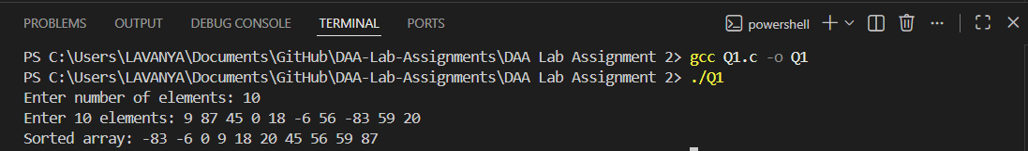

Interpretation
Bubble sort repeatedly compares adjacent values and swaps them if out of order. After each pass, the largest element “bubbles up” to the end. Time complexity is O(n²).

Q2. Insertion Sort

Question
Write a C program to sort an array using Insertion Sort.

Algorithm / Logic
- Start from the 2nd element
- Store it as key
- Shift all larger elements to the right
- Insert key into correct position
- Repeat for all elements

C Program
#include <stdio.h>

void insertionSort(int a[], int n){
for(int i=1; i<n; i++){
int key = a[i];
int j = i - 1;
while(j >= 0 && a[j] > key){
a[j+1] = a[j];
j--;
}
a[j+1] = key;
}
}

int main(){
int n;
printf("Enter number of elements: ");
scanf("%d", &n);

int a[n];
printf("Enter %d elements:\n", n);
for(int i=0; i<n; i++) scanf("%d", &a[i]);

insertionSort(a, n);

printf("Sorted array:\n");
for(int i=0; i<n; i++) printf("%d ", a[i]);

return 0;
}

Output
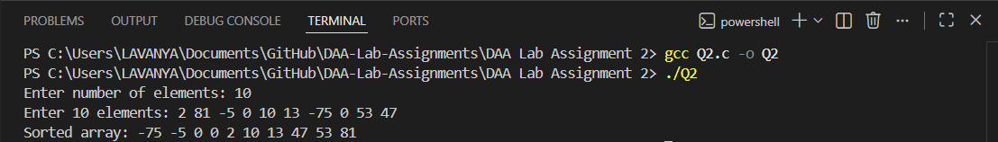

Interpretation
Insertion sort builds a sorted list one element at a time by inserting each value into its proper position. Efficient for small or nearly-sorted arrays.

Q3. Selection Sort

Question
Write a C program to sort an array using Selection Sort.

Algorithm / Logic
- For each i from 0 to n−1
- Find the smallest element in remaining array
- Swap with a[i]
- Continue until fully sorted

C Program
#include <stdio.h>

void selectionSort(int a[], int n){
for(int i=0; i<n-1; i++){
int min = i;
for(int j=i+1; j<n; j++){
if(a[j] < a[min])
min = j;
}
int temp = a[i];
a[i] = a[min];
a[min] = temp;
}
}

int main(){
int n;
printf("Enter number of elements: ");
scanf("%d", &n);

int a[n];
printf("Enter %d elements:\n", n);
for(int i=0; i<n; i++) scanf("%d", &a[i]);

selectionSort(a, n);

printf("Sorted array:\n");
for(int i=0; i<n; i++) printf("%d ", a[i]);

return 0;
}

Output
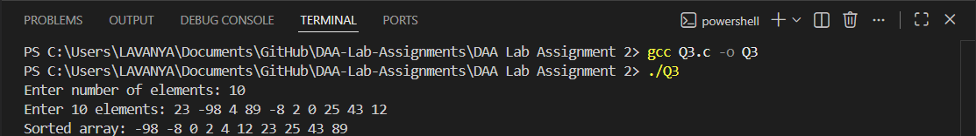

Interpretation
Selection sort repeatedly selects the smallest remaining element and puts it in the next sorted position. Always performs O(n²) comparisons.

Q4. Bucket Sort (for 0–99 integers)

Question
Write a C program to perform Bucket Sort on integers in the range 0 to 99.

Algorithm / Logic
- Create 100 buckets (array of frequency counts)
- Count each number’s occurrence
- Print numbers based on counts

C Program
#include <stdio.h>

void bucketSort(int a[], int n){
int bucket[100] = {0};

for(int i=0; i<n; i++){
bucket[a[i]]++;
}

int k = 0;
for(int i=0; i<100; i++){
while(bucket[i]--){
a[k++] = i;
}
}
}

int main(){
int n;
printf("Enter number of elements: ");
scanf("%d", &n);

int a[n];
printf("Enter %d elements (0-99):\n", n);
for(int i=0; i<n; i++) scanf("%d", &a[i]);

bucketSort(a, n);

printf("Sorted array:\n");
for(int i=0; i<n; i++) printf("%d ", a[i]);

return 0;
}

Output
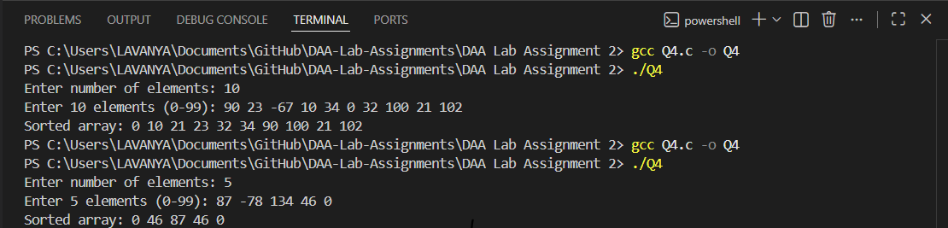

Interpretation
Bucket sort counts the frequency of each value. It is efficient when the data range is small. Time complexity is O(n + k).

Q5. Heap Sort

Question
Write a C program to sort an array using Heap Sort.

Algorithm / Logic
- Build a max heap
- Swap largest element (root) with last element
- Reduce heap size
- Heapify again
- Repeat until sorted

C Program
#include <stdio.h>

void heapify(int a[], int n, int i){
int largest = i;
int left = 2*i + 1;
int right = 2*i + 2;

if(left < n && a[left] > a[largest])
largest = left;

if(right < n && a[right] > a[largest])
largest = right;

if(largest != i){
int temp = a[i];
a[i] = a[largest];
a[largest] = temp;
heapify(a, n, largest);
}
}

void heapSort(int a[], int n){
for(int i = n/2 - 1; i >= 0; i--)
heapify(a, n, i);

for(int i = n - 1; i > 0; i--){
int temp = a[0];
a[0] = a[i];
a[i] = temp;
heapify(a, i, 0);
}
}

int main(){
int n;
printf("Enter number of elements: ");
scanf("%d", &n);

int a[n];
printf("Enter %d elements:\n", n);
for(int i=0; i<n; i++) scanf("%d", &a[i]);

heapSort(a, n);

printf("Sorted array:\n");
for(int i=0; i<n; i++) printf("%d ", a[i]);

return 0;
}

Output

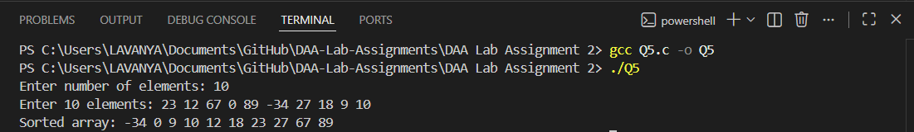

Interpretation
Heap sort uses a binary heap structure to repeatedly extract the largest element. It has O(n log n) time complexity and is more efficient than simple quadratic sorts.

